Pennywell Farm Access Statement
This access statement does not contain personal opinions as to our suitability for those with access needs but does aim to describe accurately the facilities and services offered to all our visitors.
Introduction
Situated a mile from the town of Buckfastleigh in South Devon, Pennywell Farm is a multi-award winning farm park; the biggest in the South West.
All the farm buildings, animal enclosures, activities, shows and displays are all on a level site. The average length of stay is approx. 5 hours.
There is a new activity, show or display every half hour which is supervised and led by a member of the Pennywell team. The attraction is very hands on and visitors are encouraged to touch and interact with the animals as much as possible. Hand washing is adjacent to all the areas where animals are handled and touched.
Voice boxes are located around the site.
We have a licensed restaurant, coffee shop, takeaway and gift shop all with step free access.
We have a team of friendly staff who are here to help. They all wear distinctive bright red tops and are spread around the site.
We look forward to welcoming you. If you have any queries or require assistance, please call: 01364 642023 or email: info@pennywellfarm.co.uk
Pre-Arrival
For details and maps of how to reach us, please see the ‘how to find us’ section of the website.
There are no direct public transport links to the farm due to our rural location. The nearest railway station is Totnes which is approx. 7 miles away. Taxis are available at the station. If you require an accessible taxi these can be pre booked in advance. Contact: 01626 334488
The nearest bus stop is in the town of Buckfastleigh at Station Approach. The farm is a mile and half from here up a very narrow, steep lane. The bus route is the X38 and up to date information can be found at: www.stagecoachbus.com

Car Parking and Arrival
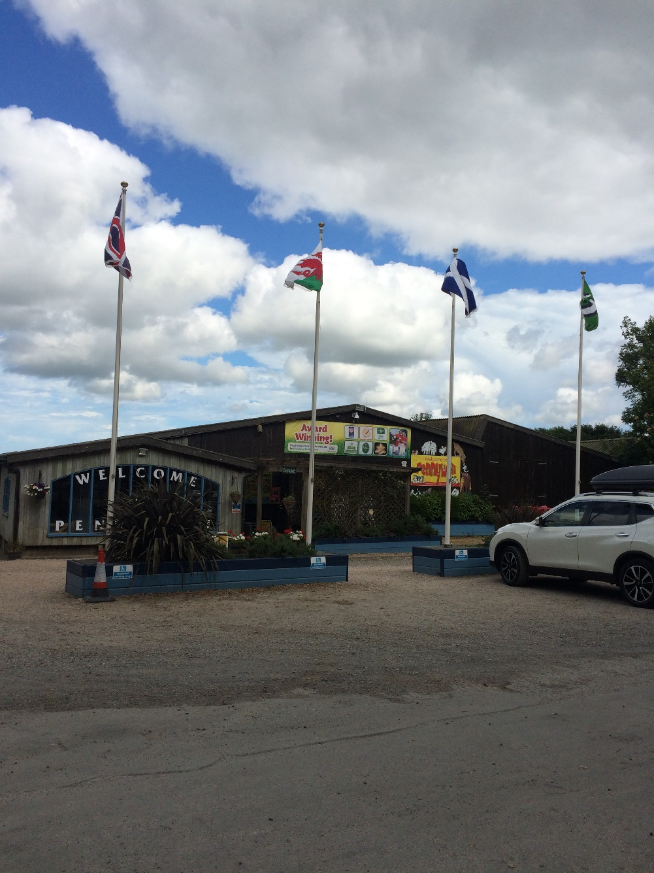
There is plenty of FREE onsite parking with 5 clearly marked Blue Badge parking spaces, directly outside of the main reception rea.
The car park is has a paved path leading to the main entrance.
There are no steps leading to the entrance / reception area.

Main Entrance / Reception Area
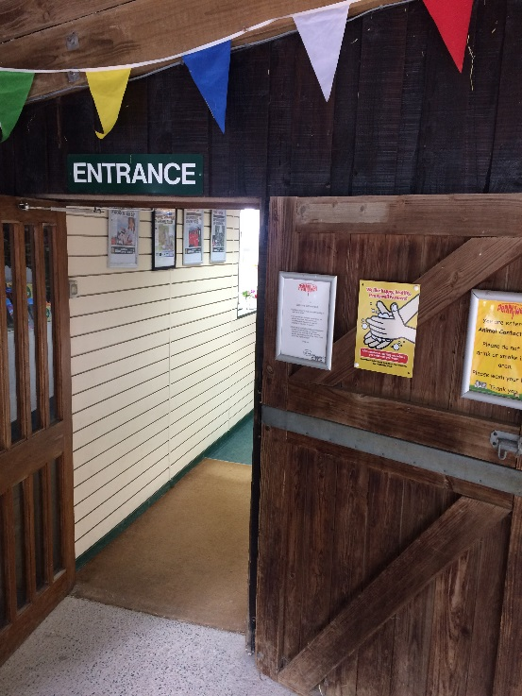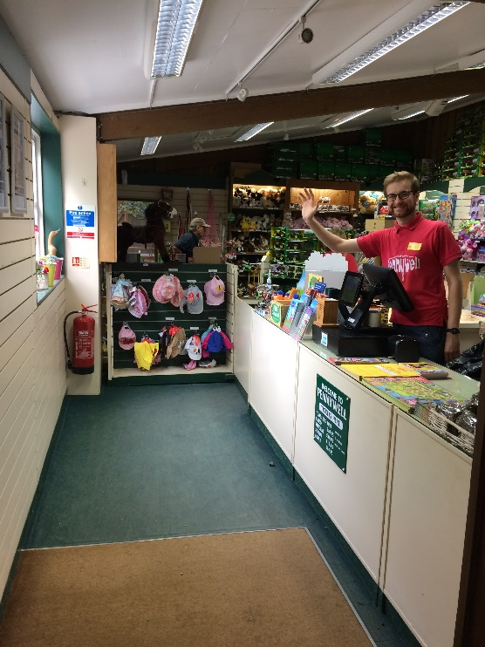
Reception is via the gift shop and has step free, level access.
The floor is carpeted and the area is well lit
The reception desk is 89 cm high and there is no screen between visitors and staff
Reception staff will give a brief introduction to the farm and give visitors information on how to get the best from their visit.
Around the Farm
There are TV screens running around the farm to give visitors visual and audio information
Tractor Ted videos are showing on large TV screens in the Tractor Village
Interpretation boards around the farm are in large, clear fonts and have pictures where applicable.
There are plenty of picnic benches around the farm and seating areas in the Café and Coffee shop.
The paths are a mix of gravel and concrete and are level.

Public Toilets
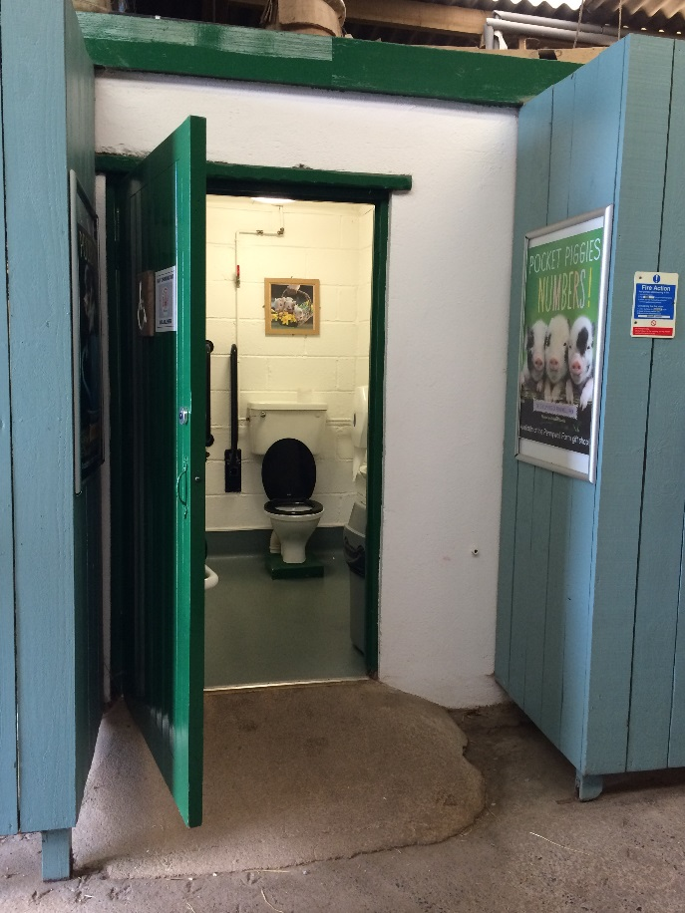
Public toilets and changing facilities are available in the Café and next to the main barn on the farm.
There is an accessible toilet next to the main barn on the farm. The toilet height is 43cms.
The flooring is non slip laminate
There are lever taps on the sink

Catering
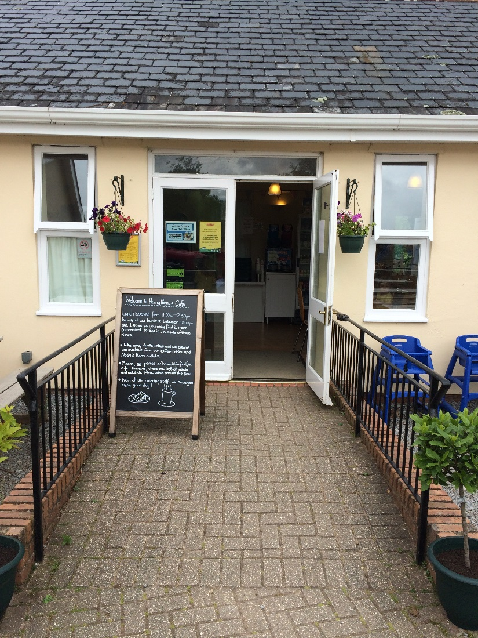
The eating outlets are all on the level.
The main restaurant, Henny Penny’s has entrance doors that are 2.5 metres wide
Tables are well spread with upright chairs without arms
Natural daylight is normally adequate but overhead lighting can also be used
The flooring in the Henny Penny’s Café is non slip laminate with wooden flooring in the Coffee Cabin. Noahs Barn has concrete flooring.
All food is locally sourced where possible and we do our best to cater for any dietary requirements. Please feel free to contact us in advance if you have any specific requests.
All food outlets are self service but staff are more than happy to assist on request.
Additional Information
All our staff receive regular training, including customer service and disability awareness training
We have a set of evacuation procedures and assistance will be given if required
Assistance dogs are welcome and we have a water bowl at the main entrance. We have kennels for all other dogs which are available free of charge.
We can offer a list of nearby accommodation providers and details of their access statements where available.
Disabled visitors and their cares are offered 10% discount on admission
Contact Information
Address: Pennywell Farm, Buckfastleigh, Devon, TQ11 0LT.
Telephone: 01364 642023
Email: info@pennywellfarm.co.uk
Website: www.pennywellfarm.co.uk
Grid reference:
Opening Hours
Local accessible taxi: Happy Cabby Taxis: 01803 559292

